https://www.eurasiareview.com/20052026-can-haitis-new-security-push-restore-the-state-oped/

Wednesday, May 20, 2026
Eurasia Review
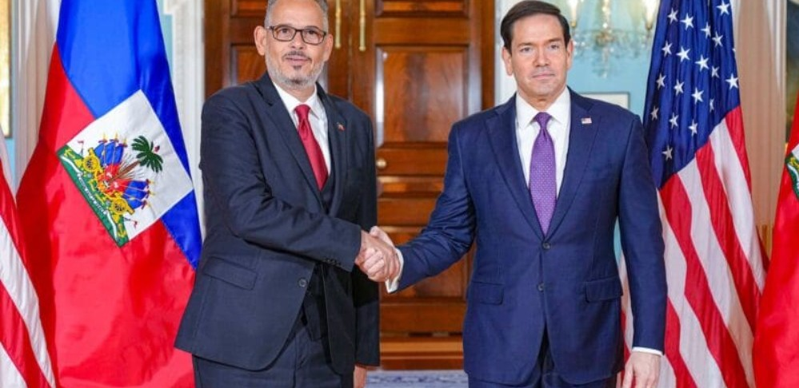
Secretary Marco Rubio meets with Haitian Prime Minister Alix Didier Fils-Aimé at the Department of State in Washington, D.C., April 21, 2026. (Official State Department photo by Freddie Everett)

Can Haiti’s New Security Push Restore The State? – OpEd
May 20, 2026
By Steven E. Hendrix
Secretary Marco Rubio’s April 21 meeting with Haitian Prime Minister Alix Fils-Aimé signals that Washington is finally recognizing Haiti’s collapse not merely as a humanitarian tragedy, but as a hemispheric security crisis. As gangs expand their territorial reach beyond Port-au-Prince into the Artibonite and Centre departments, controlling transport corridors, ports, neighborhoods, and supply chains, Haiti increasingly faces not just criminal violence, but the erosion of the state itself.
Washington’s endorsement of Haiti’s emerging Gang Suppression Force, alongside support for renewed HOPE/HELP trade preferences, signals a more serious attempt to stabilize a country whose disorder now reverberates across the Caribbean and the Americas. But the central policy question remains: can security operations alone restore Haiti’s state authority?
No—though they may be a necessary first step.
Haiti’s gangs are no longer merely armed criminal organizations. In many parts of the country, they function as alternative governance structures. They extort communities, regulate movement, control access to fuel and food, exploit children, traffic weapons, and use sexual violence as a weapon of domination. According to the United Nations, thousands have been killed or injured in the past year alone, while more than a million Haitians have been displaced, many of them children. Schools, hospitals, and aid corridors have been disrupted or destroyed. In practical terms, gangs are not simply undermining public order; they are replacing state presence.
Recent international efforts, including the Kenya-led multinational mission, have faced serious logistical and political challenges. Without courts, governance, and economic recovery, tactical security gains alone will not last.
Security can create space. But only governance can hold it.
Restoring the state requires four parallel tracks.
First, security operations must protect civilians and uphold human rights. Without accountability, security gains may deepen mistrust rather than restore legitimacy. Success should be measured by civilian safety, reopened schools, and functioning public services.
Second, Haiti’s justice system must be rebuilt alongside security gains. Courts, anti-corruption institutions, and action against the political and financial enablers of gang power are essential.
Third, humanitarian access is strategic, not secondary. Hunger, child displacement, and school collapse fuel future violence and gang recruitment.
Fourth, economic legitimacy matters. HOPE/HELP alone cannot save Haiti, but jobs and lawful opportunity remain essential to weakening gang-controlled economies.
Finally, elections matter, but premature voting without security and governance risks producing illegitimate outcomes. Haiti needs a credible transition, not symbolic ballots.
For the United States, the Organization of American States, Caribbean Community partners, and the broader international community, Haiti should no longer be treated as a recurring emergency managed through episodic interventions. The costs of failure are now regional: irregular migration, trafficking networks, democratic erosion, and chronic instability. This means more irregular migration, deeper transnational crime networks, and the continued collapse of a state within America’s own neighborhood. Haiti’s challenge is not simply defeating gangs. It is restoring the state where the state has receded.
That will require more than foreign troops, police raids, or short-term political fixes. It demands a sustained compact integrating security, justice, economic recovery, and governance reform.
The Gang Suppression Force may help Haiti reclaim territory. But territory alone is not sovereignty. Haiti’s future will depend on whether this security push can do what previous interventions too often failed to achieve: transform tactical gains into legitimate state authority.
If it cannot, Haiti will remain trapped between collapse and recovery—a nation where force may suppress violence temporarily, but cannot restore legitimate governance.

